Autobiography of Punnawit

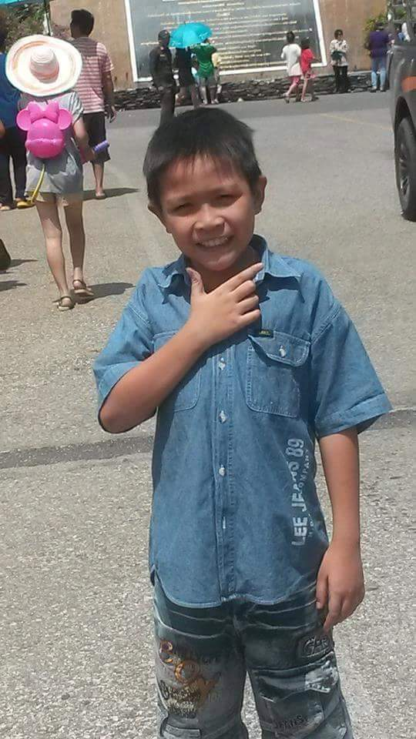Punnawit Tunphao is his name, and Pun is his nickname. His birthday is April 8, 2004, and he was born at Siriraj Hospital. Bangkok He was not stubborn and quiet as a child, got along well with friends, only had a specific group of friends, but he could talk about anything with everyone, and he loved to discover people. He is a person who does have a good appearance and He doesn't really pay much attention to people, he likes to make them laugh, and he is always ready to help them feel better.

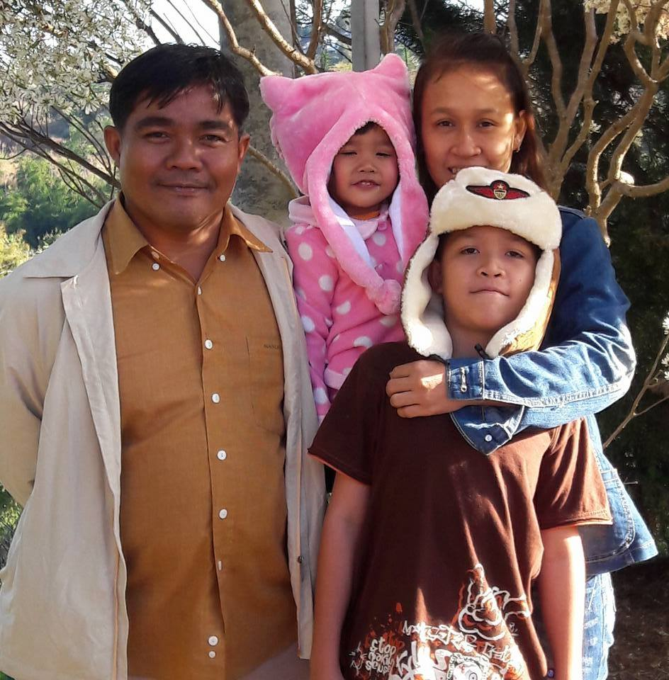 He used to live with his family at Kamnan Man 15. By living together as a family since they came together as father's brothers and sisters, and they have a problem if they stay for another ten years. Before Grandma moved to the Ekachai area and just not long ago, there was a flood in 2014, and Grandma stayed a year there at her aunt's house. Pun's father won a jackpot of over 500,000 baht and decided to return to the countryside for the 4 years that he lived there before returning to Bangkok.

Member of his family is father, mother, and sister.

His father is a man who rarely speaks and always acts. His father said his mother, on the other hand, has been a chatty and cursing person since He was a child. He is a self-indulgent yet obstinate individual. The younger brother, on the other hand, is a drinker who enjoys arguing. He used to have a dog named Ole, but It was dead. He wishes to thank you for the enjoyable times they had with him, even though he did not pay much attention to it.

Let’s talk a little about the school. 

Since kindergarten, he has attended all six schools. Dusit School was the first school and Engchai is the second elementary school. He cried out from my first admittance because it was a private school. His closest friends are Nong Nim and Guide Mo is a group of little girls. Later, He graduated and finished elementary school. His buddies moved with me to Phraya Monthat Ratchasri Phichit School. And in the year of the flood that year, he had to move to elementary school to study at Wat Ban Mai School, which is the place with the most stories. He has a large group of friends that enjoy playing practical jokes on each other. He enjoys it as well. He took the entrance exam for Trontrisin School, a junior high school. He didn't have much of a backstory  because it is so quick not enough to eat at one place, As a reason, He had to move to attend school in Bangkok Due to his lack of education, he was forced to attend school in order to broaden his opportunities. Wat Sai School is the name of this 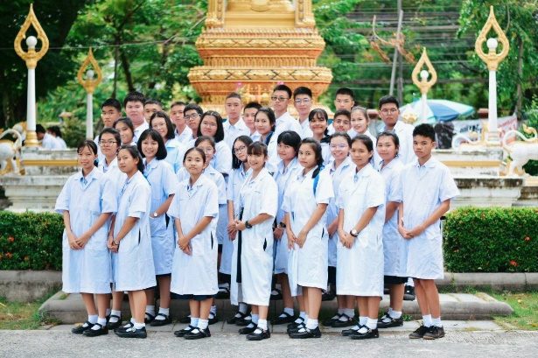location. It's a tiny school with a lot of stuff, and he's made a lot of friends and found his closest buddy his friend followed him everywhere, and he followed his friend as well and His friend's name is ball.

He graduated middle school and moved on to high school. This school is great here It has a best friend and looking forward to the next university His favorite pastime is sketching, which he enjoys because it helps him to show his creativity the best. Gaming is another activity he enjoys because it removes some of his anxiety, as well as viewing movies that he like because some of them contain beautiful things that may help build more creativity.

Design is the work of interest. He said, "Why do I enjoy it?" He believes he has the ability to sketch what is in his brain, that it is a design. Fitness is his favorite activity. My interesting career is as an architect because it is most likely the profession He mentioned. He is most likely the greatest because of my design and personal tastes, and he'll be when he is old, He simply wants a house and a car for his children and grandkids to continue doing what he enjoys. It is to see someone happy with us, whether it is a friend or a family member.

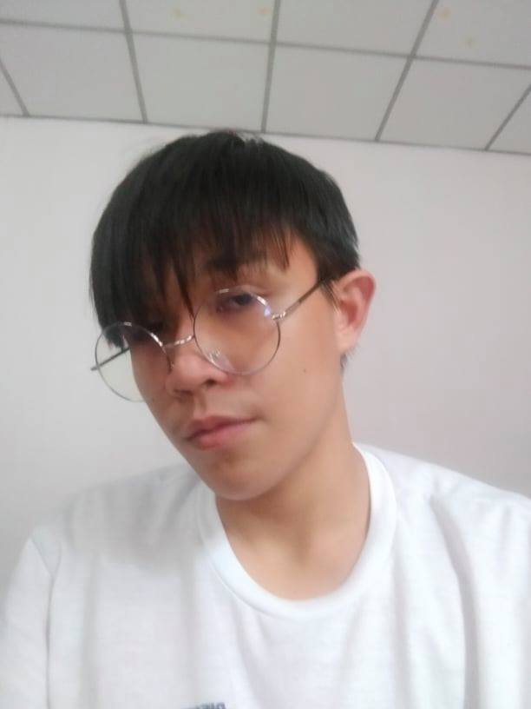

This is the biography

Of Punnawit tunphao